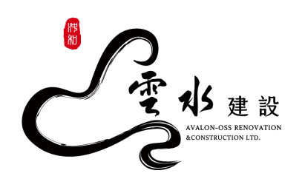
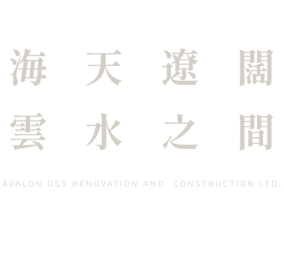

Personnel Information Form
人事資料表

Position  職位 |  |  | 1. |  |  |  |  |  |  |  |  |  |  |  |  |  |  |  | 2.

A. General Information 個人基本資料
Name  姓名 | Chinese  中文 |  |  |  |  |  |  |  |  |  |  |  |  |  | Nationality  國籍 |  |  | □ R.O.C. 中華民國 |  |  |  |  | Photo  照片
Name  姓名 | English  英文 | Yen-Lin Chen |  |  |  |  |  |  |  |  |  |  |  |  |  |  |  | □ |  |  |  |  | Photo  照片
Birth Date  出生日期 |  | mm/dd/yy  西元月/日/年 |  |  |  |  |  |  |  |  |  |  |  |  | Birth Place  出生地 |  |  | Taipei |  |  |  |  | Photo  照片
Blood Type  血型 |  | □ A ☑ B □ O □ AB □ RH |  |  |  |  |  |  |  |  |  |  |  |  | Gender  性別 |  |  | Male男 □ Female女 □ |  |  |  |  | Photo  照片
Sin Number. |  |  |  |  |  |  |  |  |  |  |  |  |  |  | Marital Status  婚姻 |  |  | Single未婚 □  Married已婚 □ |  |  |  |  | Photo  照片
Mailing Address  通訊地址 |  |  |  |  |  |  |  |  |  |  |  |  |  |  |  |  |  |  |  |  |  |  | Tel ( )
Permanent Address  戶籍地址 |  |  |  |  |  |  |  |  |  |  |  |  |  |  |  |  |  |  |  |  |  |  | Tel ( )
E-mail Address  電子郵件 |  |  |  |  |  |  |  |  |  |  |  |  |  |  |  |  |  |  |  |  | Cellphone  行動電話 |  | 778-222-9574
Military Service  兵役狀況 |  | Service  軍種 |  |  |  |  |  |  | Rank  軍階 |  |  |  |  |  |  | Status  狀況 | 免役 |  |  |  | Period  期間 | From起 Yr年 M月  To迄 Yr年 M月
 |  | Certificate No.  退伍令字號 |  |  |  |  |  |  |  |  |  |  |  |  |  | Reason of Exemption & Certificate No.  免役原因及證明字號
License or Government Certificate  專業證照 |  |  |  |  |  |  |  |  |  |  |  |  |  |  | Date of Issue  發照日 |  |  |  |  | Certificate No.  證照字號 |  |  | Remarks  備註

B. Working Experience (It is at your discretion to provide the information of supervisor and compensation.)

工作經驗 (直屬主管及薪資資料請自行斟酌是否填寫)
From 起 |  | To 迄 |  |  | Title /  On Grade Year  職稱/在職年資 |  |  | Co. Name  公司名稱  (請填入公司全名) |  | Supervisor直屬主管 |  |  |  |  |  | Compensation 薪資 |  |  |  |  |  |  | Reason  for Leaving  離職原因
M月 | Yr年 | M月 | Yr年 |  |  |  |  |  |  | Name  姓名 |  |  |  | Title  職稱 |  | Monthly Base Salary 月薪 |  | Allowance  /Bonus  津貼/獎金 |  |  |  | Others  其他 | Reason  for Leaving  離職原因
Language Ability: indicate the language and your proficiency, i.e. Excellent, Good, Useful, A little, Not at all.
語文能力：請以極佳、佳、普通、略通或不通說明您對該語文的熟練程度
Second Language and so on第2、3...外國語 |  |  |  |  |  |  |  |  | Read 讀 |  | Write 寫 |  |  |  | Speak 說 |  |  |  |  | Remarks備註
1.
2.
3.
Do you have any relatives or friends working in Avalon oss revocation and construction Ltd?目前是否有任何親屬、朋友任職於本公司？
□ No 否 □ Yes 是 If yes, please specify the name, relation and dept. 如有，請列出姓名、關係及任職部門
Name  姓名 |  |  |  | Relation  關係 |  | Department  部門 |  |  |  |  |  | Name  姓名 |  |  |  |  | Relation  關係 |  |  |  | Department  部門
Person to notify in case of emergency 緊急聯絡人
Name  姓名 |  |  |  | Relation  關係 |  |  | Address  地址 |  |  |  |  |  |  |  |  |  |  |  | Tel/Cell
Additional information you wish to add 其他補充資訊 |  |  |  |  |  |  |  |  |  |  |  |  | Have you ever committed crimes and been plead a charge?  您是否有任何犯罪紀錄或遭受起訴？  □ No否 □ Yes是 What請說明 ___________________  Are you on the wanted list?是否遭任何國家通緝？  □ No否 □ Yes是 What請說明________________
I hereby authorize Avalon Oss renovation and construction Ltd. to confirm the accuracy of all statements made on this form, and I fully understand that any false statements made herein will be sufficient cause for employment termination. I hereby agree and authorize Avalon Oss renovation and construction Ltd. to collect, handle, and use the personal information which I have provided or will provide in accordance with relevant laws about personal information protection, for purpose of Avalon Oss renovation and construction Ltd.'s personnel management.
本人玆此授權雲水建設得就本人在此陳述之內容真實性，進行確認；本人完全瞭解，任何不實陳述依法將足以構成聘僱關係之終止。本人並同意授權雲水建設基於人事管理相關業務上之目的，得在符合個人資料保護相關法令之規定範圍內進行蒐集、處理、使用本人所提供之個人資料。

Signature 簽名 Date 日期 2024/02/02
I hereby declare that I will comply with all Avalon Oss renovation and construction Ltd. regulations during my employment. In case of any violation, I agree to accept and be bound by applicable penalties as specified in the Avalon Oss renovation and construction Ltd. Work Rules and relevant rules.
本人同意並保證：本人於在職期間將遵守雲水建設所有相關規定。如有違反，本人同意接受工作規則及其他相關規定之懲處。

Signature簽名 Date日期 2024/02/02

